**Sentiment Analysis (NLP Model):**

**Introduction**

Sentiment analysis is the process of determining the emotional tone behind a body of text. we used three different models—**RoBERTa, Stanza, and GPT-3.5-Turbo**—to classify customer feedback into **Positive** and **Negative** sentiments. The accuracy of each model was evaluated based on ground truth labels.

**Dataset**

* **Source:** Channel Partner Feedback Dataset
* **Total Records:** 1,000
* **Categories:** 500 Positive, 500 Negative

Each text entry was labeled as either **Positive** or **Negative** to serve as the ground truth.

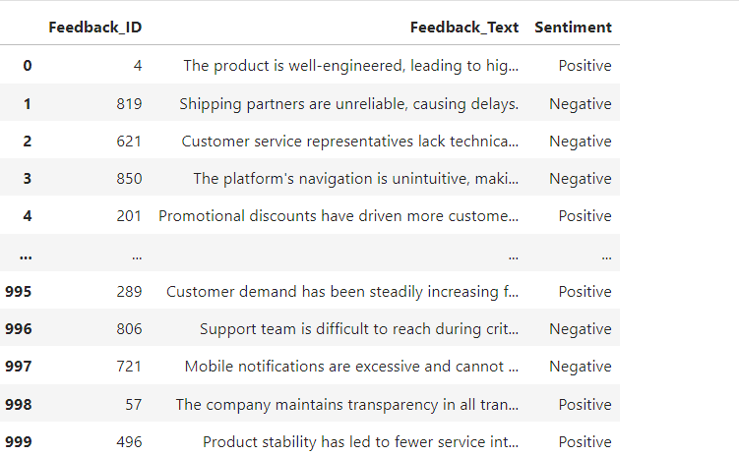

**Models Used**

1. **RoBERTa (cardiffnlp/twitter-roberta-base-sentiment)**
2. **Stanza NLP (Pretrained Sentiment Analysis Model)**
3. **GPT-3.5-Turbo (via OpenAI API)**

**Methodology**

Each model was used to classify text feedback into **Positive** or **Negative** sentiment. The predictions were compared with the ground truth labels to measure accuracy, precision, recall, and F1-score.

**RoBERTa Sentiment Analysis**

RoBERTa model trained to analyze sentiment in text. It doesn’t just look for positive or negative words—it understands the context of a sentence.

**How It Works (Step by Step)**

1. **Breaking Down the Text**
   * The model first **tokenizes** the text, meaning it breaks it into smaller pieces (words or subwords).
   * Example: *"The product is amazing, I like it!"* → ["The", "product", "is", "amazing", ",", "I", "like", "it", "!"]
2. **Understanding Context & Meaning**
   * Unlike simple word matching, RoBERTa uses **transformer-based attention** to analyze the relationships between words.
   * It knows that "not bad" is different from "bad" because it understands how words interact.
3. **Assigning Sentiment Scores**
   * The model produces three scores: **Negative and Positive**.
   * These scores represent the probability of each sentiment.
   * Example: *"The product is amazing, I like it!"*
     + **Negative: 15%**
     + **Positive: 85%** → Final Prediction = **Positive**
4. **Making a Final Decision**
   * The highest probability determines the sentiment.
   * If **Positive > 50%**, the model labels it as **Positive**, otherwise **Negative**.

**Stanza Sentiment Analysis**

Stanza is an NLP that processes text to determine sentiment. It first tokenizes the text, breaking it into words and sentences. Then, it analyzes the structure and meaning of the words before assigning a sentiment score: 0 for Negative, 1 for Positive. If a sentence has strong positive words, it is classified as Positive; if it contains strong negative words, it is classified as Negative.

**GPT-3.5-Turbo Sentiment Analysis**

GPT is a large language model that classifies sentiment based on natural language understanding rather than predefined rules or training on specific sentiment datasets. It interprets the overall meaning and intent of a sentence before assigning a sentiment

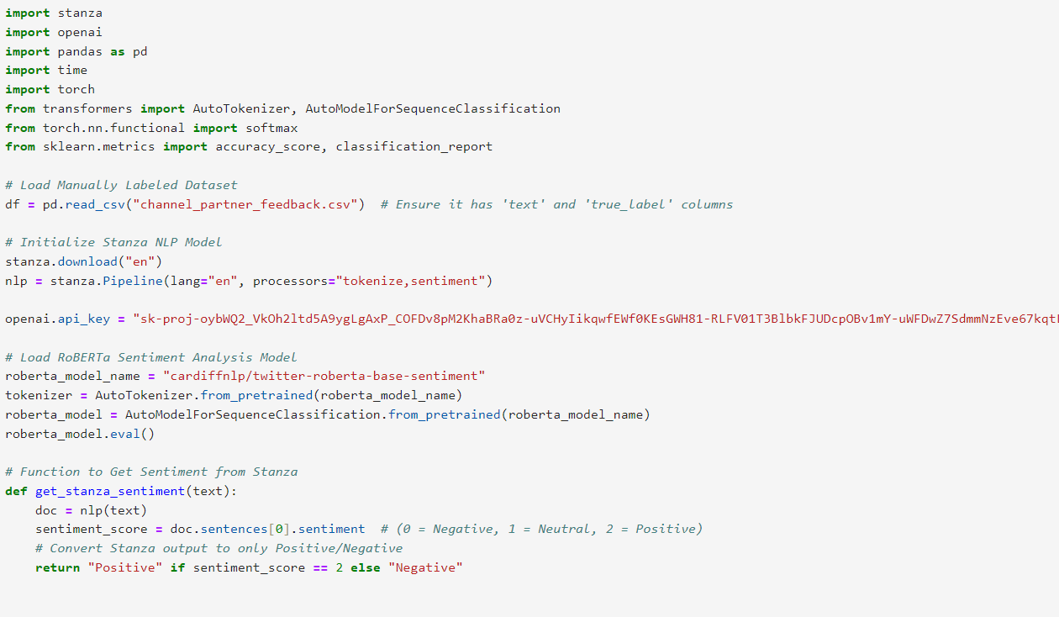

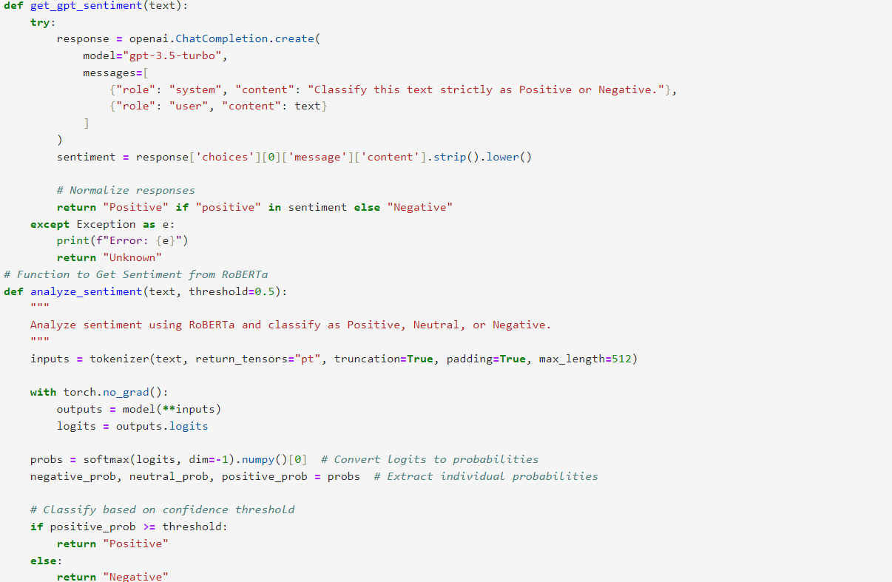

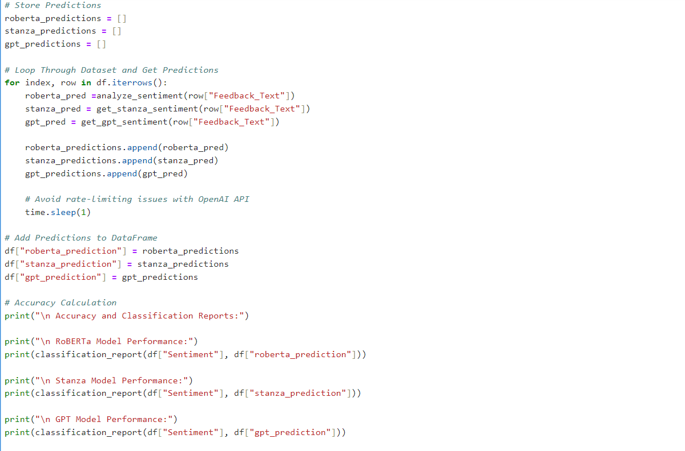

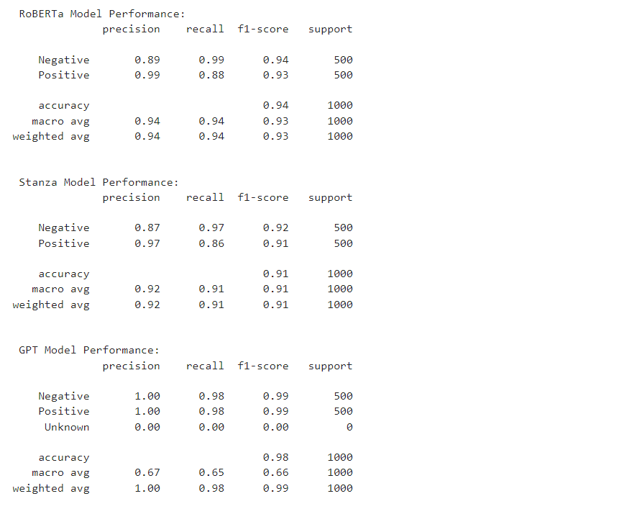

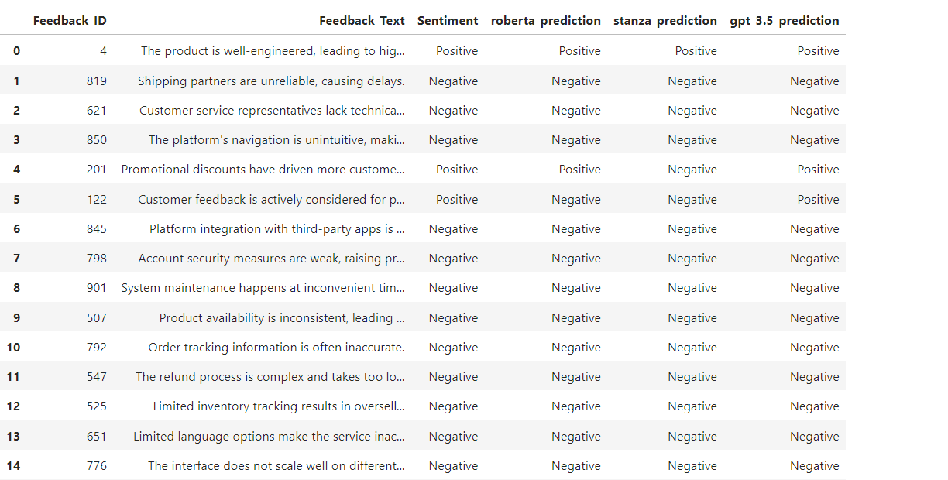

**Conclusion**

* **GPT-3.5-Turbo performed best** for strict binary classification.
* **RoBERTa is a strong contender** but needs careful threshold tuning.
* **Stanza is lightweight but less accurate** compared to transformer-based models.